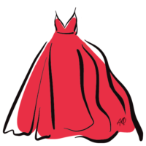
Alpha Phi Foundation Canada Red Dress Pin Order Form
Name:____________________________________________
Chapter: _________________________________________
Shipping Address:________________________________
__________________________________________________
__________________________________________________

Date of Event you need the pins by: __________________________________
Pricing & Pin Order:
All chapters can receive 60 red dress pins free each year. The chapter has to pay shipping. We encourage our chapters to give these to our members to wear in support and sell them by donation at their events.
# of Pins | Cost | Selection
60 Pins | Free
100 Pins | $30.00
140 Pins | $55.00
200 Pins | $105.00
240 Pins | $155.00
Standard Shipping | $20.00
Expedited Shipping | $30.00

Total:__________________________
Please mail this form and e-transfer the money to alphaphifoundationcanada@outlook.com . Upon receipt of the payment, we will ship out the pins to you and send you the tracking number. If you have any questions please do not hesitate to reach out to Alpha Phi Foundation Canada.

